Case Study: The Hundredth
MS | Math | Case Study | 2026-27 | Adventure

Overview
The review room is a converted equipment closet behind the pool deck, and it smells of chlorine and warm electronics.
Two monitors sit side by side on a folding table. On the left, a swimmer's hand slides toward a yellow wall. On the right, a different angle of the same instant. The Chief Judge has watched both so many times that her eyes sting. Outside, the arena is still loud; somebody has started a chant in a language she doesn't speak.
A protest form lies face-up beside the keyboard, the ink still shiny. The team leader who filed it stands near the door and says nothing at all, which is somehow louder than shouting would be. On the printout taped to the wall, the two results sit one above the other, and the gap between them is the smallest the scoring system can write.
Everyone who has to live with this call is waiting on one thing: not a verdict about two athletes, but a ruling about which instrument gets the last word when the touchpad and the human eye could tell different stories.
She taps the space bar, and the footage freezes on a single frame. Then she pulls the rulebook toward her and opens the folder with the two possible rulings.

Background
The Chief Judge is the senior official ruling on a protest at a swimming final. Her authority covers one thing: deciding which kind of evidence orders the finish when the electronic result is challenged. She is accountable to every swimmer in every final, not only this one, because whatever rule she applies tonight is the rule the next close finish will be judged under.
This decision point is constructed. In the real 2008 Olympic 100 m butterfly final, Michael Phelps was timed in 50.58 and Milorad Čavić in 50.59 (SEE APPENDIX C). Serbia protested; the referee reviewed high-speed video and the result was upheld, and FINA's ruling stands. This case does not ask you to re-try that ruling. It asks you to reason about the evidence the officials faced and about the rule that should govern evidence like it.
What the record does and does not say is set out in Appendix A. In short: the electronic result is documented, the rule text is documented (SEE APPENDIX B), but who first touched the wall is claimed differently by different named sources, and no source found publishes a measured pad delay (SEE APPENDIX F).
The two rulings in front of the Chief Judge:
- Pad Ranks. The automatic equipment orders the finish, as the rule is written. The reported times differ, so the swimmer with the lower reported time is ranked ahead, applied identically to every race.
- Contact Ranks. Where the pad and the eye could disagree, high-speed video of first hand contact orders the finish, because first contact is what a race is meant to reward.
There is no "dead heat" ruling available. The reported times are not equal, and the rules award a shared placing only to equal times at one-hundredth of a second (SEE APPENDIX B). The question is which instrument orders the finish, not whether the finish is a tie.
One idea runs through the numbers. A touchpad registers a touch a short time after the hand arrives. If that delay is the same for both swimmers, it cancels out when the two are compared. Only a difference in delay between the two lanes can make the pad's order differ from the order of first contact. How big that difference could plausibly be is not measured in any source found; this case asks you to state a range and defend it (SEE APPENDICES E AND F). Every figure here is cited (SEE APPENDIX G) or declared an assumption (SEE APPENDIX F). The vocabulary and "how to…" skills this case asks you to research are listed in Appendix H.

Dilemma
You are the Chief Judge.
Do you:
A.) Rule Pad Ranks — the touchpad result orders the finish, as the rule is written OR
B.) Rule Contact Ranks — first hand contact on high-speed video orders the finish

Challenges
1.) Research and find an online resource that answers one of the "how to…" questions from the case study launch. Post a link to the resource as your submission.
2.) Post 250 or more "excellent" words pitching a firm stance to your audience on which you would choose and why. Your pitch must include: a.) Use of the "how to…" resource you researched in Challenge 1. b.) At least one original visual display of the data.
3.) Your pitch must include:
- D1 — Speed and distance per hundredth. Using Appendix C's distance and winning time, calculate the winner's average speed in metres per second, then the distance (in centimetres) a hand travels in one hundredth of a second at that speed. State in one sentence why this is only an approximation near the wall.
- D2 — A frame-rate band table. For each frame rate in Appendix D, calculate the time between frames (seconds) and the distance a hand travels between frames (centimetres) at your D1 speed. State which frame rates can separate a one-hundredth difference (meaning the time between frames is shorter than 0.01 s) and which cannot.
- D3 — The range hiding inside "0.01 s". Appendix B says the third digit is not recorded or used. Calculate the smallest and largest true pad-time difference consistent with reported times of 50.58 and 50.59 if (i) the third digit is simply dropped and (ii) the time is rounded to the nearest hundredth. Give each as an interval, in seconds and in centimetres (say whether the ends can actually be reached), and state whether the case can treat the margin as exactly 0.01 s.
- D4 — A differential-lag table and your plausible range. Complete Appendix E's table: for each differential lag, calculate the first-contact margin it implies, using the reported 0.01 s pad margin, and state who touched first. Then state the range of differential lag you consider plausible, defend it using the named claims in Appendix A as claims (not facts), and name the single value above which the pad and first contact disagree.
- D5 — A reliability comparison. Using Appendix E's rule for an instrument's indecision band, calculate each option's band, its probability of ordering a close finish correctly, and the percent difference between the two options (larger minus smaller, divided by the smaller, times 100), first with Appendix E's scenario values and then with your own range from D4. State which option wins on each.
- D6 — What the model leaves out. In a short written section, name at least three things this model leaves out or simplifies, say which one most threatens your recommendation, and name one measurement that would settle it.
4.) An appendix showing evidence of your original thinking, work, calculations and processes you used to complete the challenges (pictures, screenshots, notes, etc.). Your work in the appendix does not count toward your word count.
5.) Participate twice or more in the Case Study discussion. *If you are absent the day of a discussion post 500 "excellent" words on the questions above.

Appendix A — What the Record Says, and Who Says It
Referenced in Background and Challenge 3 (D4). Facts first, then claims. A claim is attributed to the person or organization that made it and is not a finding of this case.
Documented facts.
Item | Value
Event | Men's 100 metre butterfly final, 2008 Summer Olympics, 16 August 2008 [S2]
Reported results | Phelps 50.58; Čavić 50.59; third place 51.12 [S1]
Serbia's team protested | Reported by ABC News on the day [S3]
FINA's decision | FINA said it was convinced Phelps reached the wall ahead of Čavić, and rejected the protest [S3]

Claims, each attributed to its source only.
Who | What was said | Source
Serbia's protest, as reported by ABC News | Čavić touched first but did not apply enough force to trigger the timing sensor | [S3]
Ben Ekumbo, referee, as reported by NBC News | He reviewed the footage and found the Serbian swimmer touched second: "One was stroking and one was gliding"; the judgment came from the footage, not the human eye | [S4]
Omega's Christophe Bertaud (also spelled "Berthaud" elsewhere), 2009 video interview, as reported by Swimming World | Čavić did touch the wall first, and Phelps's force on the pad stopped his clock one hundredth of a second sooner | [S5]

These claims point in different directions on first contact, and this case does not choose between them. Bertaud's statement comes from a single source, and his name is spelled two ways across sources. No source found gives the frame rate of the footage the referee reviewed, and no source found publishes a pad delay for either swimmer. One reference work reports a pad activation force, but a different figure than other write-ups, so this case uses none (SEE APPENDIX G, EXCLUDED FIGURES).

Appendix B — The Rule Text
Referenced in Background and Challenge 3 (D3). FINA's swimming rules, as published in the 2009-2013 edition (in force from 23 September 2009, the first edition after this race) [S6], with the same wording carried in the 2015-2017 edition [S7]:
Rule | What it says (paraphrase)
SW 11.1 | Times recorded by automatic equipment are used to determine the winner, the placings and each lane's time, and take precedence over timekeepers. If the equipment fails, or a swimmer failed to activate it, the timekeepers' recordings are official. [S6]
SW 11.2 | With automatic equipment, results are recorded only to one hundredth of a second. When thousandths are available, the third digit is not recorded or used to determine time or placement. Swimmers with the same time at one hundredth share the same placing. [S6]
SW 13.1 | Placings and times determined by automatic officiating equipment take precedence over timekeepers. [S6]
SW 13.4.2 | For combining heats (earlier rounds, not a final; this is not the rule that gives a shared placing, which is SW 11.2): swimmers with tied official times are tied in their relative order of finish. [S7]

Edition caveat. The edition in force on race day (2005-2009) could not be retrieved. This case therefore does not claim the 2008 wording; the 2009-2013 text above is the closest edition found. The rule text says the third digit is "not recorded or used"; it does not use the word "round".

Appendix C — How a Finish Works, and the Race Figures
Referenced in Background and Challenge 3 (D1, D3).
How a finish works, in plain words.
- Butterfly finish. Both hands reach forward and touch the wall at the end of the race. A swimmer can be stroking (still pulling with the arms right up to the wall) or gliding (arms already stretched out, coasting in).
- Touchpad ('the pad'). A large plate fixed to the wall at the end of each lane, which is what a swimmer touches (the yellow wall in the Overview is the pad). Picture a thin plate that has to be pressed in a little before it closes an electrical contact and stops that lane's clock. A light graze might not close it; a firm press does. So the moment the pad registers comes slightly after the moment a hand first reaches the wall: the time for the plate to be pressed far enough. That delay is the pad lag. In this case's model, the lag in a lane depends on how the hand arrives: a hand still driving into the wall (stroking) presses firmly at once, while an outstretched hand coasting in (gliding) may rest on the plate and need longer to press it in. Why the two lanes' lags could differ is exactly the open question; no source measures it (SEE APPENDIX F).
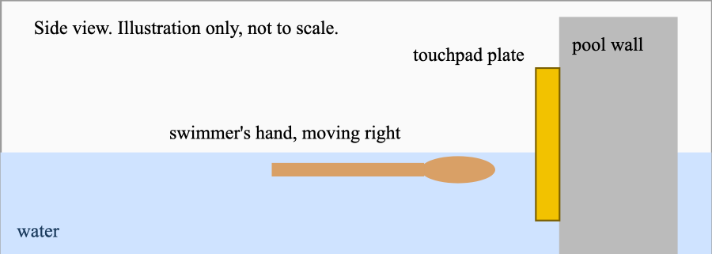
- Differential lag. The pad lags in both lanes. A lag that is the same in both lanes cancels when you compare the two. Only the difference between the two lanes' lags matters for the order.
- Automatic equipment vs timekeepers. The pads and the clock they stop are the automatic equipment. Timekeepers are officials with handheld stopwatches, who are the back-up.
- FINA is the international governing body that wrote the swimming rules. A protest is a formal written complaint to the referee, who decides it. The Chief Judge in this case is the senior official ruling on it.
- Placing, tie and dead heat. A placing is a finishing position (first, second). A dead heat is a tie, where two swimmers share a placing.
- Frame rate. A video is a series of still frames. At 60 frames per second a new still image is taken every 1/60 of a second; anything that happens between two frames cannot be seen exactly. To judge first contact, a judge steps through the footage frame by frame and looks for the first frame in which a hand is on the wall. That is why the gap between frames limits how exactly the moment can be placed, and why a judge cannot be exactly sure which frame to call (the extra band J).
- Thousandths. The clock can count finer than a hundredth of a second, for example 50.584. The rule says the last digit is not recorded or used, so the printed result is 50.58. (Whether a real clock drops that digit or rounds it is part of what D3 asks you to consider.) Heats are the earlier rounds of an event; this was a final, so SW 13.4.2 below is shown only for completeness.
- Team leader. The official who speaks for a country's swimmers and is allowed to file a protest.
- Referee and Chief Judge. The referee is the official who rules on protests in a real meet. In this constructed case the Chief Judge is the senior official holding that ruling role, and is a role, not a real person.
Figure | Value
Race distance | 100 m [S1]
Reported winning time (Phelps) | 50.58 s [S1]
Reported second-place time (Čavić) | 50.59 s [S1]
Reported third-place time | 51.12 s [S1]

Appendix D — Review Footage Frame Rates
Referenced in Challenge 3 (D2). These are four example frame rates for comparing kinds of footage, listed as scenario inputs (SEE APPENDIX F, MA2). The frame rate of the footage actually reviewed in 2008 was not found.
Footage type | Frames per second
Ordinary television | 30
Faster television / phone slow-motion | 60
High-speed camera | 240
Very high-speed camera | 1000

Appendix E — The Differential-Lag Table and the Reliability Rule
Referenced in Challenge 3 (D4, D5).
Sign convention. Let the differential lag be Δ = (pad lag of Čavić) − (pad lag of Phelps), in seconds. Let d be the pad-time difference, Čavić minus Phelps. Let c be the first-contact margin, Phelps's contact time minus Čavić's: c > 0 means Čavić touched first. Then c = Δ − d.
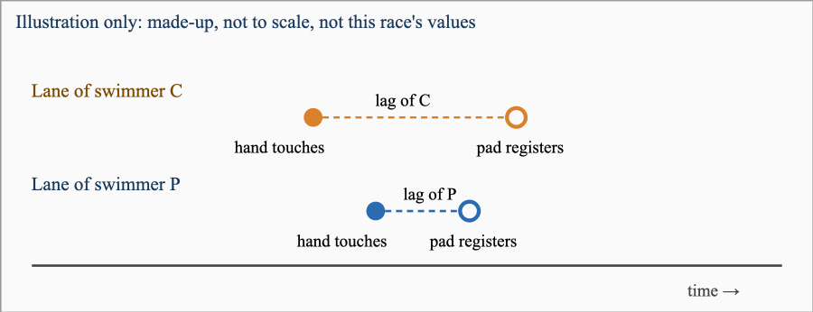
In this made-up picture C's hand touches first (c > 0) but C's lag is longer, so P's pad registers first (d > 0): the pad and first contact disagree. That can only happen when the lag difference Δ is larger than d.
The plausible range of Δ is not measured. The grid below is a sweep for you to work through, not a claim that any value is measured or likely.
Δ (s) | c (s) = Δ − d, with d = 0.01 s | Who touched first?
−0.010 | (D4) | (D4)
0.000 | (D4) | (D4)
0.005 | (D4) | (D4)
0.010 | (D4) | (D4)
0.015 | (D4) | (D4)
0.020 | (D4) | (D4)
0.030 | (D4) | (D4)

The reliability rule (a model, used in D5). Call a finish "close" if the true first-contact margin c is equally likely to be anywhere from −W to +W seconds. An instrument with an indecision band of b seconds orders any finish with |c| < b correctly only half the time, and orders the rest correctly. So its probability of ordering a close finish correctly is
P = 1 − b ÷ (2 × W)
- Option A (Pad Ranks): b = |Δ|.
- Option B (Contact Ranks): b = (time between frames) + J, where J is the extra band a judge needs to call first contact from the footage.
Percent difference means (larger P − smaller P) ÷ smaller P × 100.
A worked example with made-up numbers (not this race). Suppose W = 0.04 s and an instrument's band is b = 0.01 s. The finishes with true margin between −0.01 s and +0.01 s are 0.02 ÷ 0.08 = 25% of all close finishes. Inside that zone the instrument cannot tell the order, so it is right only half the time (it loses half of 25% = 12.5%). Outside the zone it is always right. So P = 1 − 0.125 = 0.875, which is also 1 − 0.01 ÷ (2 × 0.04). The pad's band is |Δ| because it can only misorder a finish whose true margin is smaller than the difference between the two lanes' delays; the footage's band is the gap between frames plus the extra band J because a moment that falls between two frames, or a hand-contact a judge cannot pin to one frame, cannot be placed any more exactly than that. In short: the pad can only misorder two hands whose true arrival times differ by less than the difference between the lanes' delays, and footage can only misorder two arrivals that fall within about one frame (plus the judge's reading band) of each other.
Scenario values for D5 (declared, not measured; SEE APPENDIX F): Δ = 0.010 s, J = 0.005 s, frame rate 240 frames per second, W = 0.05 s.

Appendix F — Modeling Assumptions
These figures are not sourced. They are stated scenario assumptions chosen by the case author. The lag range is a plausible range, not measured. A Hero may challenge any of them in discussion, and that is a legitimate move. The answer is sensitive to these values.
# | Assumption | Value used | Basis | Sensitivity
MA1 | The differential pad lag Δ between the two lanes | Swept from −0.010 s to 0.030 s (Appendix E); scenario value 0.010 s for D5 | Plausible range, not measured. No published lag figure for either swimmer was found, and no lag number is attributed to Omega or FINA. The two named claims in Appendix A point in different directions about who pushes or glides, and about force on the pad. | The answer is sensitive to this value.
MA2 | The frame rate of the footage under review | 240 frames per second (scenario value); Appendix D lists four examples | The frame rate of the footage reviewed in 2008 was not found. | The answer is sensitive to this value.
MA3 | The judge's extra reading band J for calling first contact | 0.005 s | No source gives a figure for how precisely a judge can call first contact from footage. | The answer is sensitive to this value.
MA4 | What counts as a "close finish": true margin equally likely anywhere within ±W | W = 0.05 s | A definition for this model, chosen to span a few centimetres of hand travel either way; not a measurement. | This sets the scale of P but a change of W moves both options the same way.
MA5 | Hand speed near the wall | The D1 average speed is used | The average speed over 100 m is a stand-in; a stroking hand moves faster and a gliding hand slower. | Affects centimetre conversions only, not the timing comparisons.

Appendix G — Sources
# | Claim | Value | Source | Date | Confidence
S1 | Reported times, men's 100 m butterfly final | 50.58 / 50.59 / 51.12 | Olympedia, Men's 100 metres Butterfly, 2008 | accessed 2026-10-03 | HIGH
S2 | Date and the existence of a Serbian protest | 16 Aug 2008 | Wikipedia, Swimming at the 2008 Summer Olympics, Men's 100 metre butterfly | accessed 2026-10-03 | MEDIUM
S3 | FINA's decision; Serbia's alleged grounds | as attributed | ABC News, FINA throws out protest against Phelps | 2008-08-16 | MEDIUM
S4 | Referee Ekumbo's statements | as attributed | NBC News, Video, timing systems confirm Phelps' 7th gold | 2008-08 | MEDIUM
S5 | Omega's Bertaud: Čavić touched first; Phelps's force on the pad stopped his clock sooner (single source) | as attributed | Swimming World, Mark Spitz allegedly claims Michael Phelps did not win 2008 100 fly Olympic gold | accessed 2026-10-03 | MEDIUM
S6 | SW 11.1, 11.2, 13.1 wording (2009-2013 edition) | as paraphrased | FINA, FINA Swimming Rules 2009-2013 (copy hosted by Bahamas Aquatics) | enforced 2009-09-23 | MEDIUM
S7 | SW 13.4.2 and the same SW 11.2 wording (2015-2017 edition) | as paraphrased | FINA, Swimming Rules 2015-2017 (copy hosted by the Slovenian federation) | 2015-09-07 | MEDIUM
S8 | Winner's average speed, derived: 100 m divided by 50.58 s | 1.977 m/s | derived from S1 | n/a | HIGH

Excluded figures. A touchpad activation force appears in secondary write-ups, with different values in different places and no primary source; it is not used. A claim that Serbia "accepted" the footage was not used, as the case could not confirm it from a named primary source. The 2005-2009 rule edition (in force on race day) could not be retrieved.

Appendix H — "How To…" Math Questions To Research
Vocabulary terms
- Unit
- Ratio
- Decimal
- Percent
- Rounding
- Estimating
- Range
- Probability
- Absolute Value
"How to…" questions
- How to convert an amount with compound units
- How to divide decimal numbers
- How to multiply decimal numbers
- How to subtract decimal numbers
- How to round a number to a specified place value
- How to evaluate a variable expression (Substitution Property)
- How to evaluate an absolute value expression
- How to determine the probability of a single event
- How to convert numbers to percents
- How to compare two or more values

